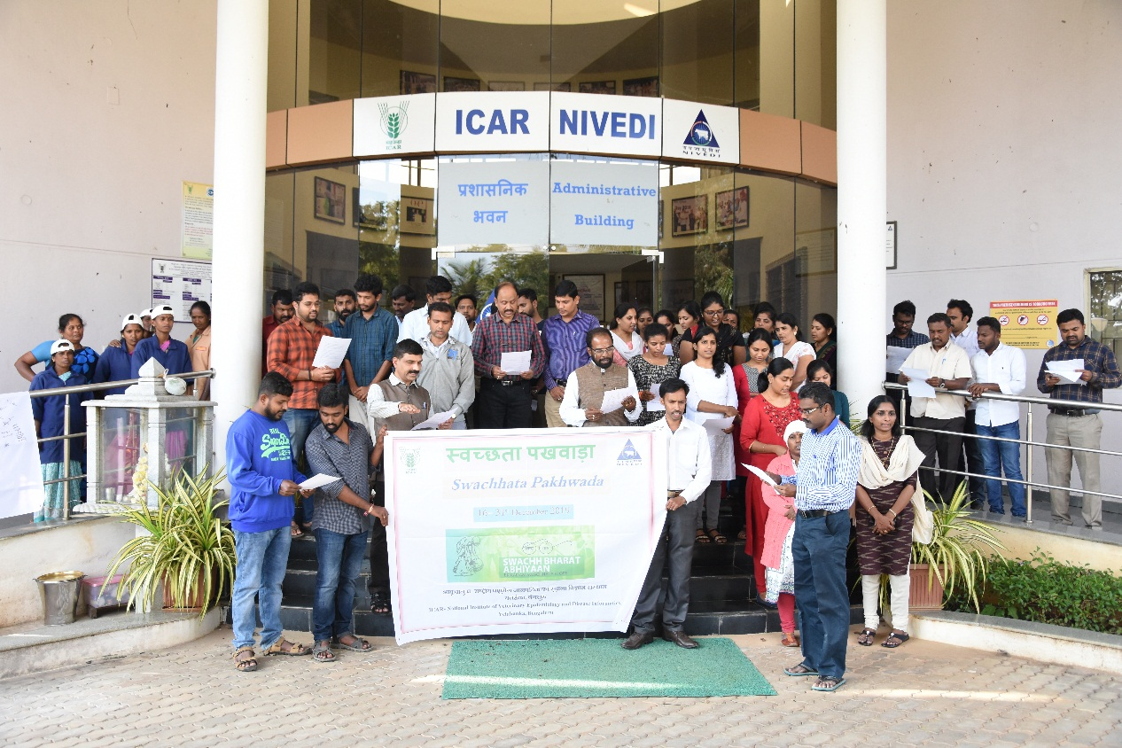
Swachhata Pakhwada: Kisan Diwas
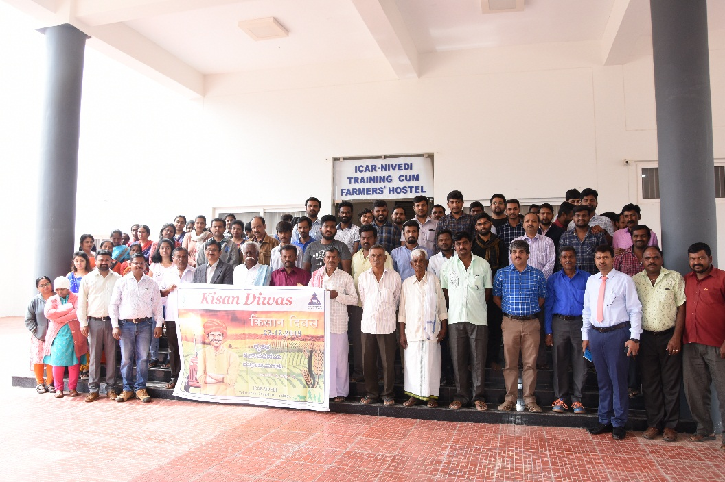

Cleaning of public places, community market places and/or nearby tourist spots

The selected tourist places of Nandi Hills and temple areas outside ICAR-NIVEDI campus were cleaned by all the members of the team with slogans about the “Swachh Bharat-Ek Kadam Swachhta Ki Ore”, “Clean Village-Healthy Village”. We collected lots of plastic materials spilled on the road side and dumped into the municipality bin. Apprised each household about proper disposal of waste material including their segregation.
Ready…Steady…..Move on…….WITH MISSION…
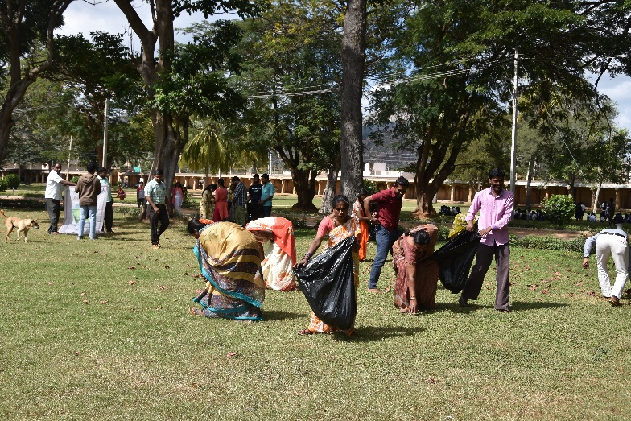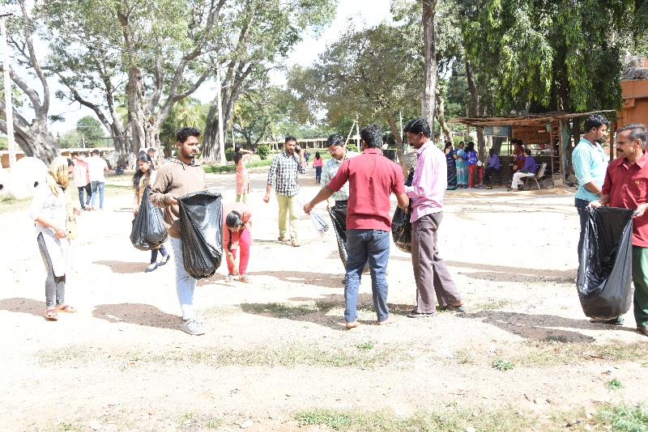
Volunteers in Action…..
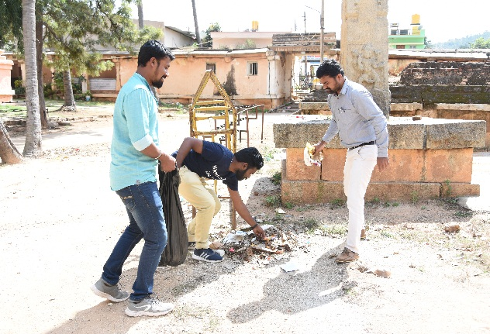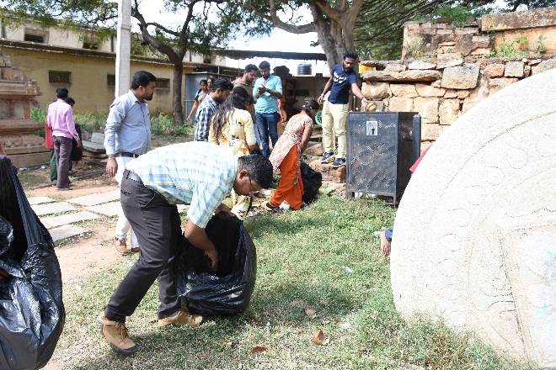
Gathering the plastic materilas/wastes
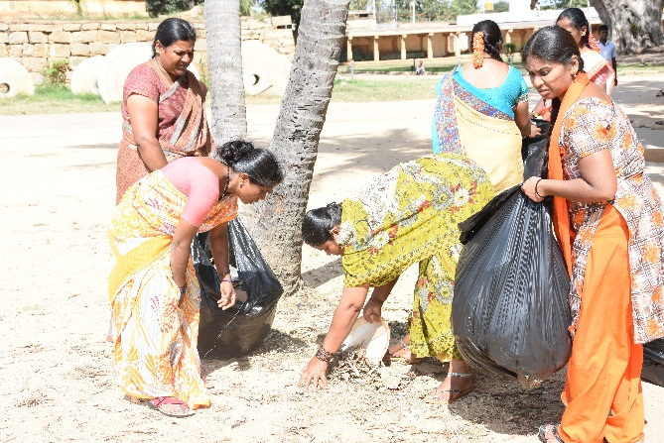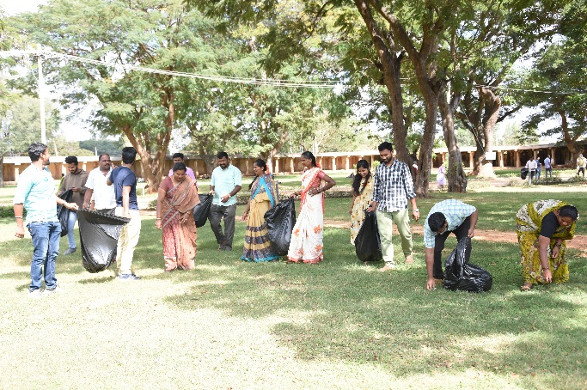
Collecting the wastes…..
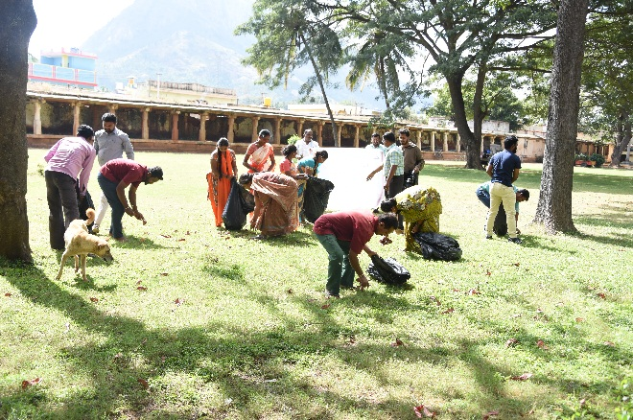
Pooling of the wastes……..
